**Evaluation (Accuracy And Losses)**

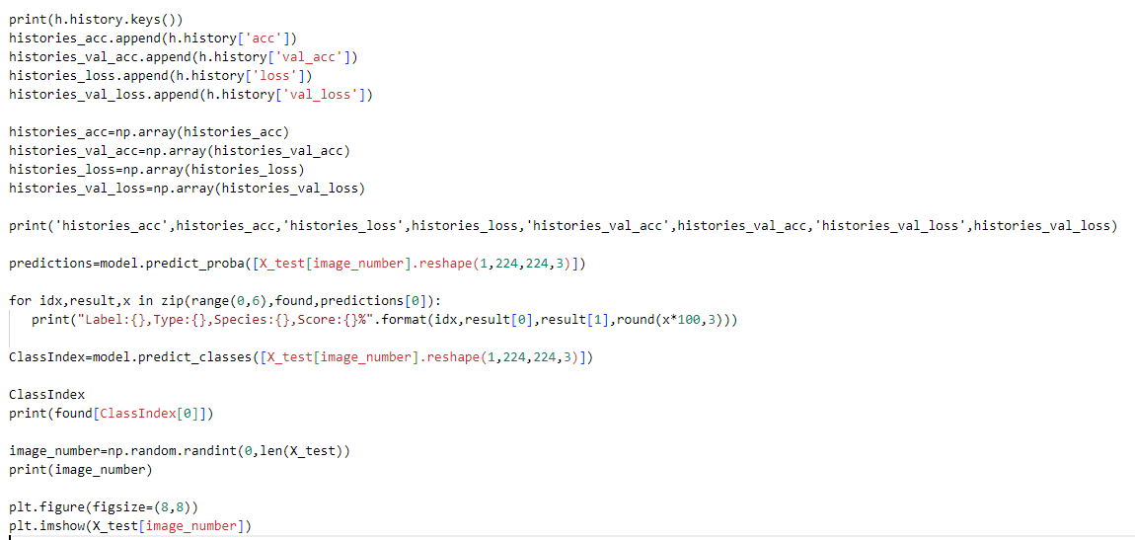

**Model Saving and Lading**

